St. Albans Area Watershed Associations’ 9th Annual
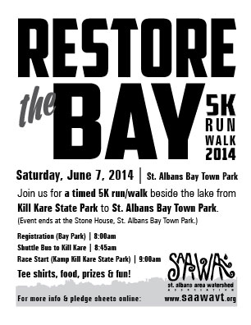
RESTORE THE BAY 5K! – Registration Form

A 5K Walk/Run beginning at Kill Kare State Park
Please park at St. Albans Bay Town Park to be transported by bus to the start

Saturday June 7, 2014

SCHEDULE:
8:00 a.m. Registration (Bay Park)
8:45 a.m. Runners/Walkers take shuttle bus to KillKare State Park
9:00 a.m. Race begins at Kamp KillKare State Park

Refreshments, Awards & Prizes

Can Pre-register by mailing prior to SAAWA ▪ P.O. Box 1567 ▪ St. Albans VT 05478
Mail completed form with payment of $20 payable to SAAWA – 1st 75 received are guaranteed a T-Shirt

Participant Name
Address
Phone |  |  |  | E-mail Address
Participant Age |  | Check One |  |  | Male _______ | Female ________
Shirt size  (not guaranteed) | Adult S _____ Adult M ______  Adult L _____ Adult XL ______ |  | Check One |  | Running _______ | Walking ________

I hereby release the St. Albans Area Watershed Association and all volunteers and sponsors of the “Restore the Bay 5K” from any liability for injuries or damages sustained by me or my property in connection with this event as a participant or observer. I further attest that I am physically conditioned to safely participate in this event and do so at my own risk. I realize that I will be running or walking on public thoroughfares that are not closed to traffic and I am fully responsible for my own health, safety and wellbeing.

Signature: _______________________________ Print Name: _________________________ Date: ___________________

(Guardian signature required if under 18)

